

**Inter-Association Leadership Education Collaborative**

Funded by the C. Charles Jackson Foundation

***Summer Summit 2014 Proceedings***

In June 2013, seven participating organizations, the National Clearinghouse for Leadership Programs (NCLP), the National Association for Campus Activities (NACA), the Association for Leadership Education (ALE,) the Association for College Unions International (ACUI), the International Leadership Association (ILA), the American College Personnel Association (ACPA) and the National Association of Student Personnel Administrators (NASPA) came together for the premiere Inter-Association Leadership Collaborative (ILC) Summit at the University of Maryland. After a year of intentional conversation and reflection, the Collaborative directed its focus on leadership education. As a result, the Collaborative newly identified itself as the Inter-Association Leadership Education Collaborative (ILEC). On June 19, 2014, the seven founding associations, joined by the American Association of University Women (AAUW), reconvened at the University of Maryland to discuss new directions and achievable strategic initiatives for 2014-2015. Bruce Jackson, Executive Director of the C. Charles Jackson Foundation which sponsored this year’s Summit, joined the Collaborative to discuss the outcomes of our work. A University of Maryland sponsored opening reception was held to recognize the eight organizations for their participation and to acknowledge the foundation for their support of the Summit. Dr. Linda Clement, Vice President for Student Affairs, welcomed ILEC members to the university and wished the Collaborative a productive Summit.

Group ILEC.tiff



***In Picture: Tony Andenoro (ALE), Dave Dessauer (NCLP), Bill Smedick (NACA), Akeel Alleyne (UMD), Bruce Jackson (C. Charles Jackson Foundation), Brian Magee (ACUI), Dan Jenkins (ILA), Craig Slack (UMD), Sandra Rouse (NACA), Shelly Wilsey (ILA), Julie Owen (NCLP), Tricia Fechter (ACPA), Melissa Rocco (ACPA), Melissa Burgess (ACUI), Kim Kushner (NASPA), Meghan Murphy (UMD), Lillian Rosen (UMD), Christine Hernandez (AAUW), Lindsey Hammond (NASPA), and Kelleen Stine-Cheyne (ALE).***

**Table of Contents**

Introduction…………………….1

Participants……………………..2

Mission, Vision, and Objectives………………………..3

The State of

Leadership…………………....…3

Benchmarking…………………4

Shaping the Narrative...……5

Moving Forward……………...5

The focus of this year’s Summit revolved around benchmarking as it relates to the leadership education field itself, the entirety of higher education, as well as organizations and agencies outside of higher education. Participants formed work teams to address these three distinct components: Internal Benchmarking, Competitive Benchmarking, and Functional Benchmarking. The following 2014 Summit outcomes reflect the team-building framework created and advanced by Patrick Lencioni in his book *The Five Dysfunctions of a Team*. The Summit planning committee felt that framing discussions around this model would prompt constructive and meaningful conversation.

**2014 Outcomes**:

* Build trust within the ILEC as a whole as well as in our work teams
* Uncover conflict and use it to gain positive result
* Gain commitment to the ILEC, work teams, vision, and goals
* Create accountability for the ILEC and work teams
* Become results-oriented as the ILEC and work teams

**The Parts of the Whole: Participating Organizations**

*To understand how the ILEC works together, it is first imperative to recognize the unique contributions that each individual organization makes to the collaborative. All participating organizations and their respective representatives offer differing expertise, skills, and resources that highlight their niche in the realm of leadership education. A firm understanding of each individual organization allows representatives to distinguish how the strengths of one group feed directly into the weaknesses of another and provide exposure to the relevant leadership education work being completed by other organizations. True collaboration builds on the strengths of individuals to produce a strong collective.*

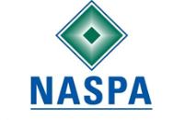

**The American Association of University Women (AAUW)** advances equity for women and girls through advocacy, education, philanthropy, and research. Each year, AAUW’s campus leadership programs shape the lives of thousands of college women to be the next generation of leaders.

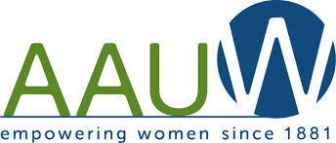

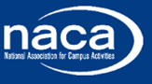

**The National Association for Campus Activities (NACA)** advances campus activities in higher education through a business and learning partnership, creating educational and business opportunities for its school and professional members.

**NASPA: Student Affairs**

**Administrators in Higher**

**Education** is a community within

the larger organization that strives to

serve as a resource for higher education

professionals who have a professional

interest in young-adult

(i.e., college students) leadership

training, education, and development. The KC fulfills their mission through a number of initiatives, including supporting national and regional efforts to develop student leadership programs, making contributions to the literature, recognizing exemplary programs, and cultivating a forum for the presentation of new ideas.

**ACPA—College Student**

**Educators International** is a   
 community within the larger  
 organization that creates a   
 space for the active learning,   
 education, research, and advocacy for anyone working with or interested in student activities at post-secondary institutions.

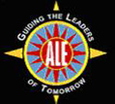

**The Association of College**

**Unions International (ACUI)**

works to support its

members, the majority

of whom work in college

unions around the world,

in the development of

community through education,

advocacy, and the delivery of service.

**The Association of Leadership Educators (ALE)** is an organization that works to

strengthen and sustain the

expertise of professional

leadership educators. ALE houses the Journal of Leadership Studies.

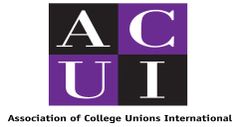

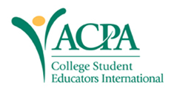

**The International Leadership**

**Association (ILA)** is a global

network for all those who practice,

study and teach leadership. The ILA

promotes a deeper understanding

of leadership knowledge and

practices for the greater good

of individuals and communities

worldwide. ILA has over 2400 members

from more than 70 countries, predominantly in North America, Europe, and Asia-Pacific.

**The National Clearinghouse**

**for Leadership Programs (NCLP)**

through the development of

cutting edge resources, information

sharing, and symposia, supports

leadership development in college

students by serving as a central source of professional development for leadership educators. The NCLP also works to connect leadership educators to one another and support those developing leadership programs in their communities.

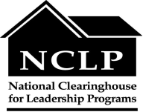

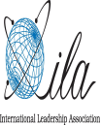

**Bringing the Big Picture Into Focus: The Mission,**

**Vision, and Objectives That Undergird Our Work**

**Collaborative Conversation: The State of College Student Leadership**

To be effective in its mission, the ILEC realized that it needed to evaluate the state of leadership education. Its evaluation yielded many trends for the Collaborative to focus on including:

* A shift away from *what* experiences foster leadership growth (e.g., service-learning, workshops) to *what about* these experiences fosters growth.
* Whether or not all leadership-based activities on college campuses are having any real impact on the macro-level (e.g. campus, community and/or societal betterment).
* The need to think beyond individual (participant) outcomes from leadership programs to more large-scale impact-oriented outcomes.
* The need for multidisciplinary involvement in leadership education.
* Whether or not our concern with creating safe spaces in our collegiate programming does our students a disservice when they enter the world by creating a false reality or false expectations.
* Service-learning/community-based education within leadership programs.
* The contradiction between leadership theory in the classroom and leadership practice in the working world (non-hierarchical vs. hierarchical).
* The dominance of Western values, political ideologies, and economic motivations in the field of leadership education.
* How to motivate students to participate in leadership programs who normally would not.
* Access to the resources necessary to produce programs conducive to leadership development.
* How to find ways to assess students as they enter programs so as to create a meaningful experience that builds on whatever previous knowledge they have.

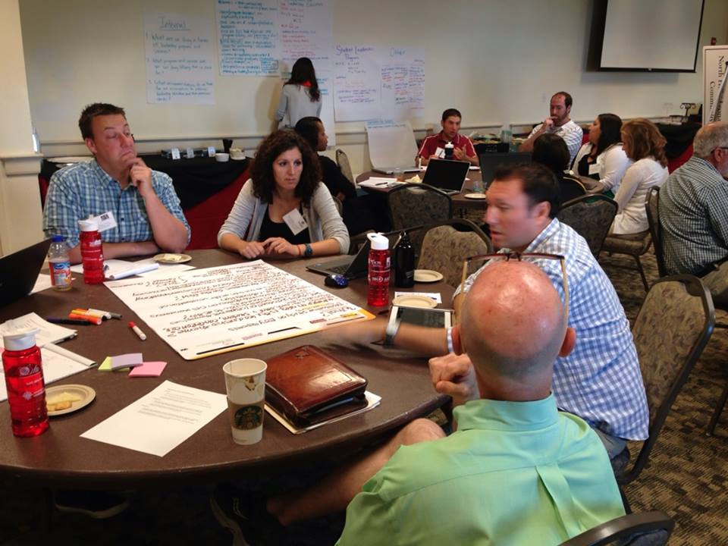

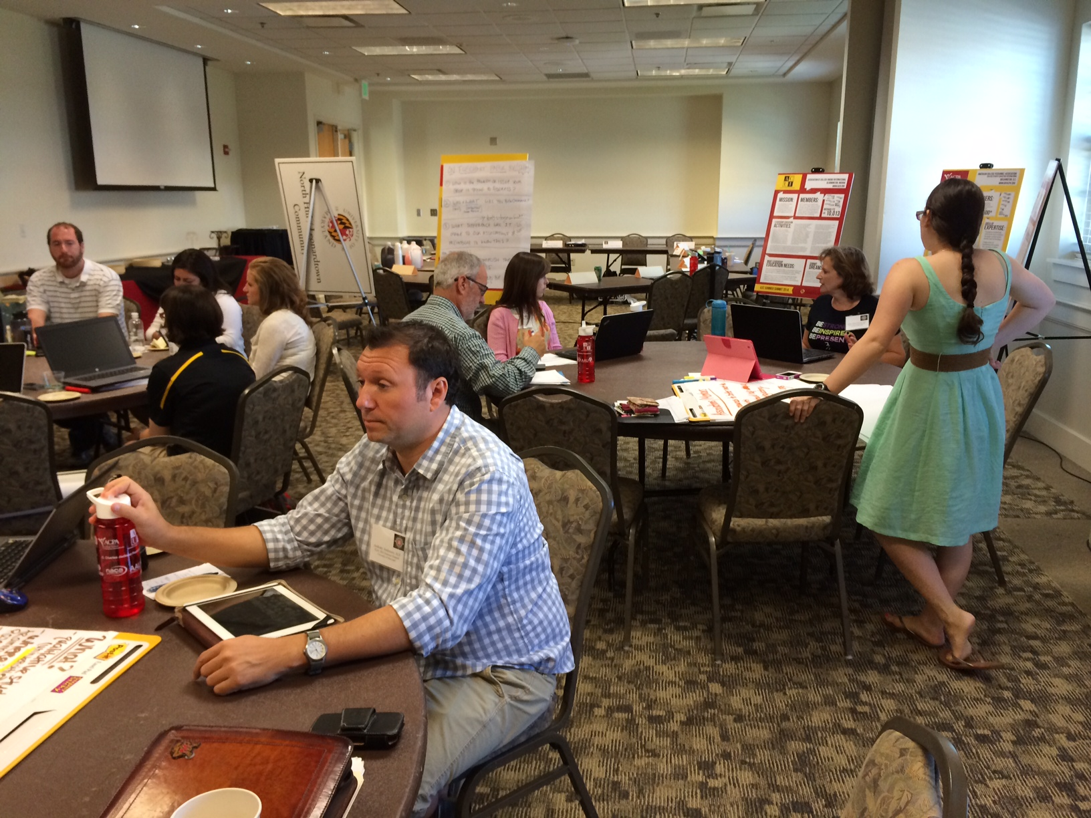

**Collaborative Benchmarking**

Once the state of leadership had been assessed, the ILEC split into three different groups—Internal, Competitive, and Functional—to address what was happening in the leadership education field among its own member organizations, other associations within higher education, colleges and universities, and groups outside of higher education

**Shaping the Narrative and Moving Forward**

Leadership educators are faced with the daunting task of preparing leaders to serve in complex, adversity-filled, adaptive contexts. Unfortunately, there is no blueprint for these contexts--or is there? ILEC representatives used facilitated dialogue to create the included conceptual model, which can be used as a reflective lens to examine current practice within leadership education contexts.

The model is vertically progressive starting with Integrated Intentionality. This implies that leadership education should be grounded in an intentional foundation, supported by Telos (focused purpose) and passion for the task of educating the next generation of leaders. As the model progresses, specific inputs are identified (Subversive Engagement, Sincere Connections, Investment in Potential, and Inclusive Dialogue) leading to the Development of Transformative Leadership Learning Opportunities, which are indelibly linked to Authentic Challenges. The Learning Opportunities create the possibility for sustaining our legacy as a discipline through the development of Holistic Community Reciprocity grounded in Social Justice. Through this process, we actualize our calling as leadership educators. This vertically progressive model also works in the inverse. The inverse provides us with the means to communicate the “Why, How, & What” of leadership education and prioritizes the assessment and evaluation of our academic and student development initiatives.

ILEC Concept Map 2014.tiff

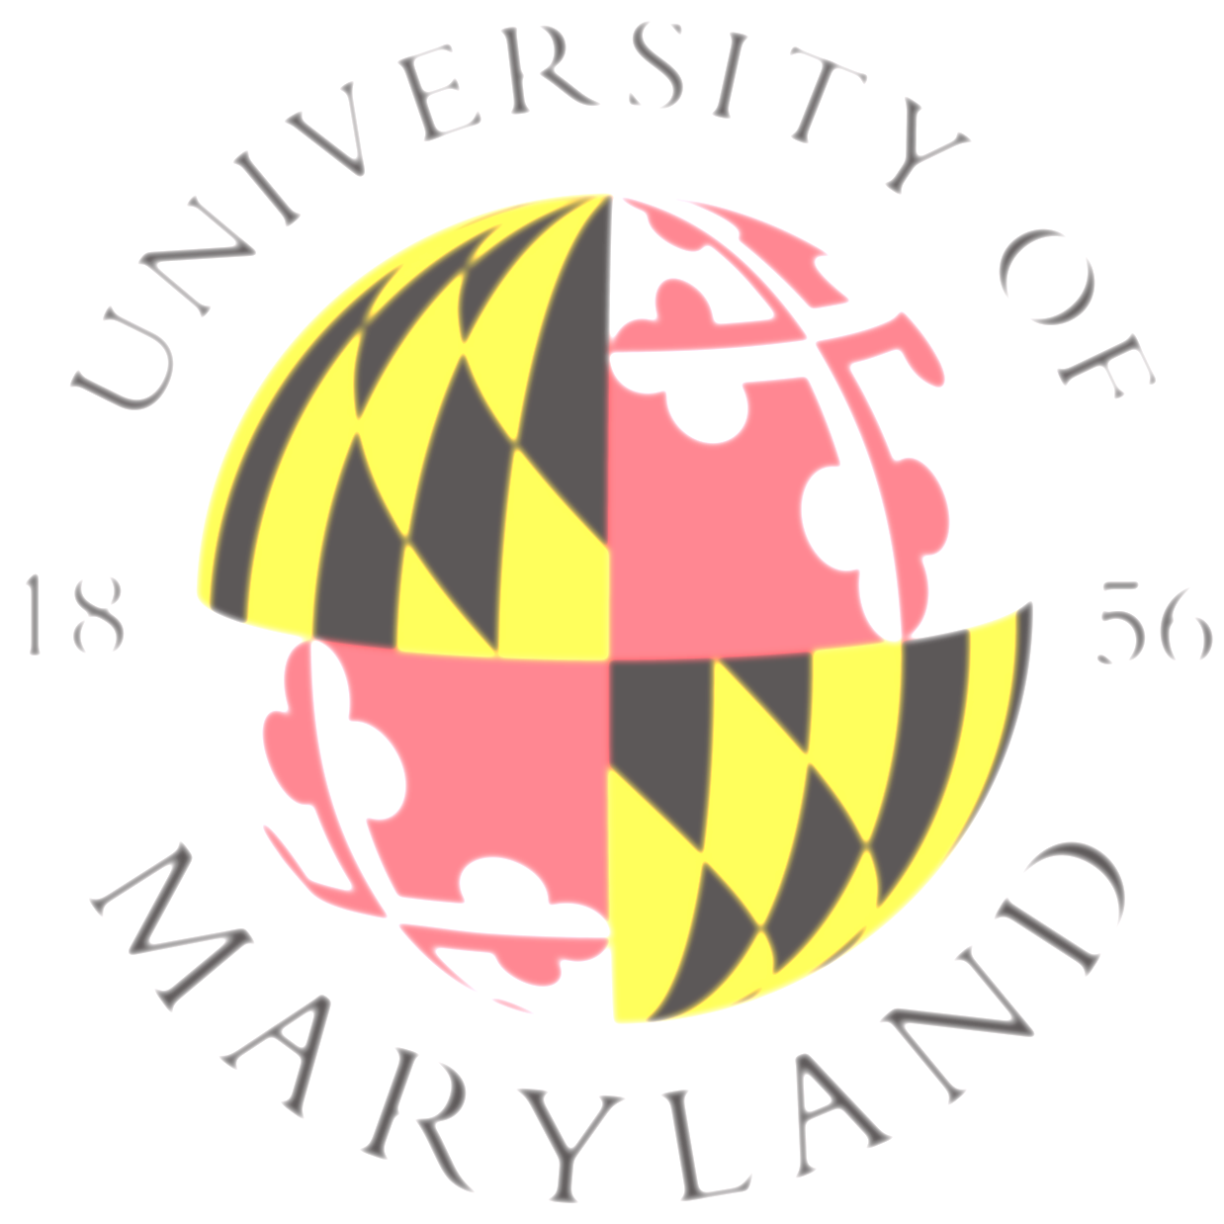

The attendees want to thank those who were instrumental in the execution of the 2014 ILEC Summer Summit, including the C. Charles Jackson Foundation, the ILEC Summit planning committee(Dave Dessauer, Julie Owen, Bill Smedick), Tony Andenoro, Kim Kushner, the University of Maryland, and the staff members of the University of Maryland Stamp Student Union. For more information on the ILEC and its work, please contact Craig Slack at 301-314-7104.

In an effort to continue ILEC conversations, four conference call meetings will be scheduled throughout the year. Each benchmarking work team will also be responsible for virtually convening and sharing the progress made toward their respective 2014-2015 Strategic Initiatives. The Collaborative also discussed creating a Google Group or Listserv that would disseminate up-to-date, association-specific information to all ILEC representatives. Representatives would be able to report their personal and their association’s successes, challenges, current projects, and upcoming projects once a month through this medium. It was proposed that this information be sent out on the 30th of every month.