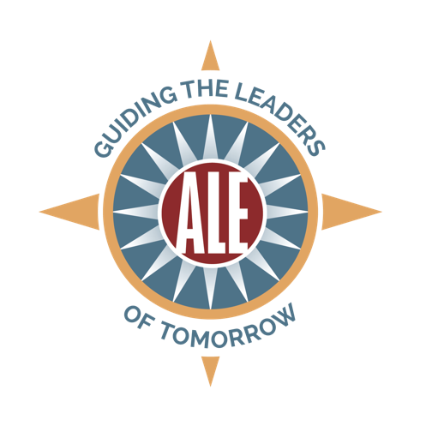

SPONSORSHIP OPPORTUNITIES

Association of Leadership Educators Annual Conference
July 16-19, Nashville, TN

$10,000 | $7,500 | $5,000 | $2,500 | $1,000
5 registrations | 4 registrations | 3 registrations | 2 registrations | 1 registration
Full-page color ad (conference program) | Full-page color ad (conference program) | Half-page color ad (conference program) | Quarter-page color ad (conference program) | Quarter-page color ad (conference program)
Logo on conference website | Logo on conference website | Logo on conference website | Logo on conference website | Logo on conference website
Prominent  Exhibit | Prominent  Exhibit | Standard  Exhibit | Standard Exhibit
Verbal recognition at three plenaries | Verbal recognition at two plenaries | Verbal recognition at one plenary
Conference bag insert | Conference bag insert
Prominent signage at conference

Additional Conference Sponsorship Opportunities

Custom Sponsorships Available For:
- Opening reception
- Dinner and tour excursion
- Food and beverage breaks
- Conference travel and registration scholarships
- Conference Bags
  - $1,000 (full color sponsor logo on conference bag)*
- Conference Bag Inserts
  - $450 (sponsoring entity provides materials)

Exhibitor Opportunities

- Corporate Exhibitor
  - $500 (standard exhibit space)
- University or College
  - $250 (standard exhibit space)
- Non-profit Exhibitor
  - $250 (standard exhibit space)

Ads (Conference Program)

- Inside front cover
  - $500 (7.5” x 10" / Color)*
- Back cover
  - $450 (7.5” x 10" / Color)*
- Inside back cover
  - $425 (7.5” x 10" / Color)*
- Full page
  - $200 Black and White (7.5” x 10")
  - $400 Color (7.5” x 10”)
- Half page
  - $150 Black and White (7.5” x 4.75”)
  - $250 Color (7.5” x 4.75”)
- Quarter page
  - $100 Black and White (4.75” x 3.5”)
  - $150 Color (4.75” x 3.5”)

* Exclusive

